**Continuous Integration**

**Jenkins**

Jenkins (<https://jenkins-ci.org/>) is an open source continuous integration tool, providing a wide-variety of integration services for software development. Our Test and Production build/deployments have been configured through Jenkins. Jenkin’s clones the source code directly from GitHub and then performs the necessary build tasks and deployment procedures. All jobs will execute on a defined schedule, but can be performed on an ad hoc basis.

1. 18F Testing Automation runs **Selenium** Automation Test scripts and performs **SonarQube** analysis. Completion of 18F Testing Automation will automatically trigger the deployment of 18F Test Deployment.
2. 18F Test Deployment deploys the application code, cloned from our GitHub master branch, to the Test Server cluster.
3. 18F Production Deployment deploys the application code, cloned from our GitHub release branch, to the Production Server cluster.

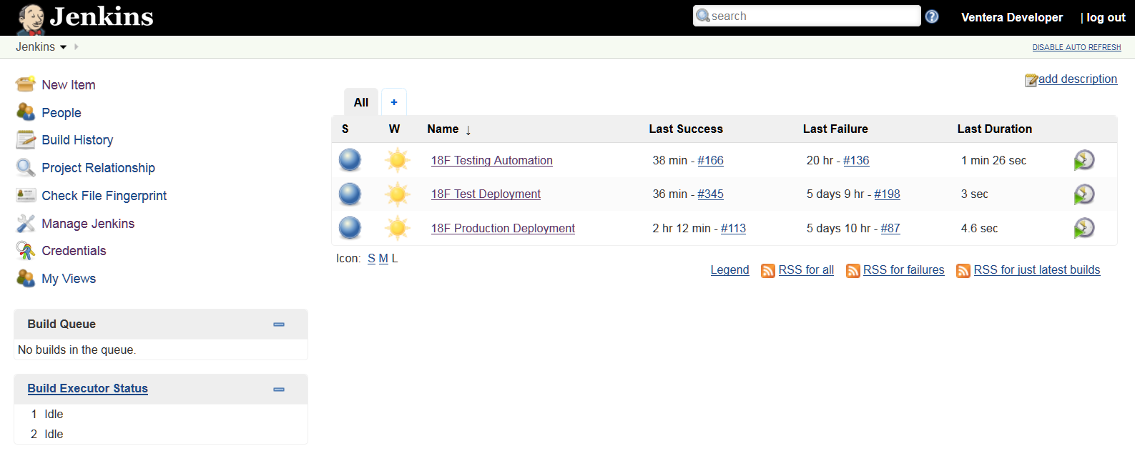

* 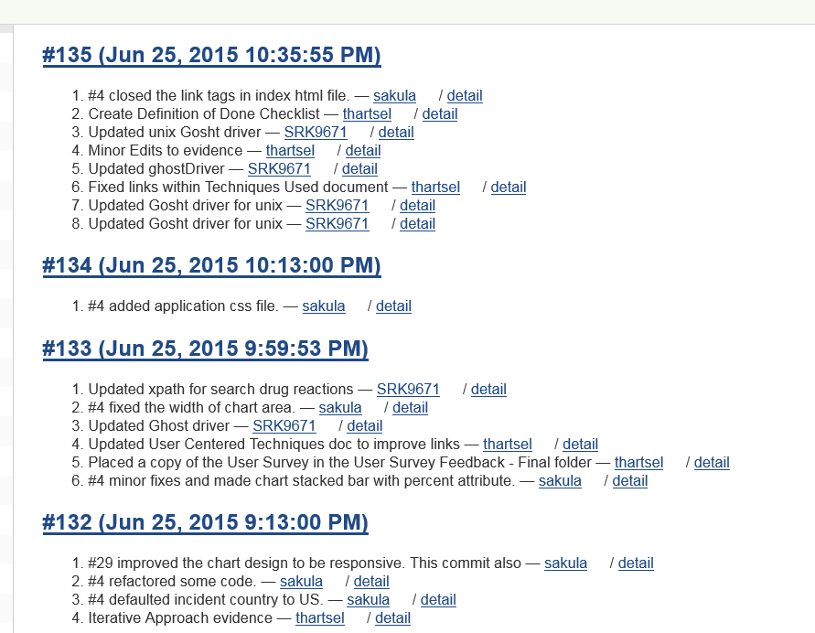
* **Selenium Automation Testing**
  + Created a flexible and extendable and easy to maintain automation testing framework project using Maven, Selenium WebDriver and TestNG.
    - **Maven:** It provides pom.xml which is the core of the project. This is a configuration file were are the configurations are saved. It manages are dependencies and different flows for building a project.
    - **Selenium Webdriver:** Used to automate web browsers across many platforms.
    - **TestNg:** Used for reporting. It structures, groups and launches tests.
  + **Implementation:** 
    - Created Maven project with the below structure

Src/main/java: contains packages with page objects and packages with reusable components and test configurations.

Src/main/resources: contains test data, test properties and drivers.

Src/test/java: contains packages with test scripts. All the application related functionality is automated and placed in this package.

* + - Created reusable components which can be used across projects in BaseTestUtil. These methods are used across the test scripts.
    - Created page objects to maintain all the objects in a page and and to specific the operation of the webobject.
    - Created test scripts by calling the objects and methods written in page object package.
    - Created assertions across the scripts to check if a required step is passed or failed.
    - Parameterization: Data is passed from an excel sheet and user can modify as to which data to be run.
    - Test Configuration: In POM.xml, configuration can be done as on which browser the test needs to be run and on which URL specific tests to be run.
    - Test running is done through TestNG and output is checked in xml file.
  + **Test Scripts:** Below are the test scripts created
    - F18LandingPageTest
    - F18EnterDrug
    - F18GetDrugReactionsAll
    - F18GetDrugReactionsFemale
    - F18GetDrugReactionsMale
    - F18GetDrugReactionsSerious
  + Jenkins is configured to perform headless (no graphical output) testing using GhostDriver and Phantom JS browser. Firefox and Chrome testing configurations also exist.

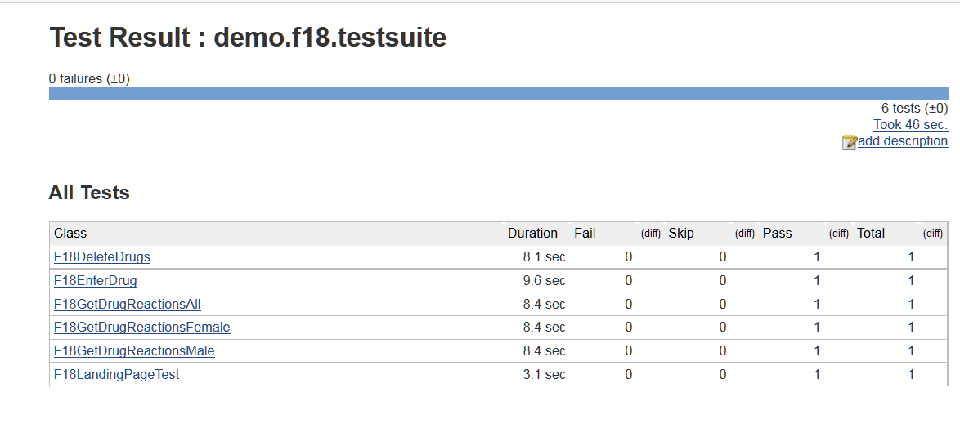

* **SonarQube**

SonarQube (<http://www.sonarqube.org/> ) is an open source quality management platform, which continuously analyzes and measures code quality against a defined set of rules and regulations. Our source code and Karma test classes are analyzed with SonarQube Javascript metrics, as part of every Jenkins build/deployment to the Test environment. SonarQube results are reported at the following location: <http://54.175.69.234:9000/dashboard/index/26>

